**Payments and Transfers Instructions**

**Option 1)**

1. From the home page, select the **?** Icon, found to the far right on the green Home bar.
2. From the left menu bar, select **Payments and Transfers**, then **Transfers** and follow the instructions on how to complete a transfer.

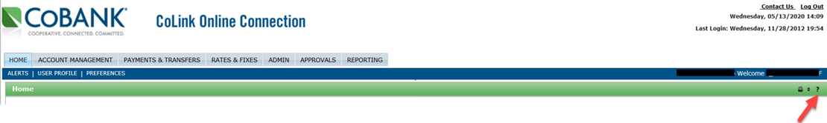

1



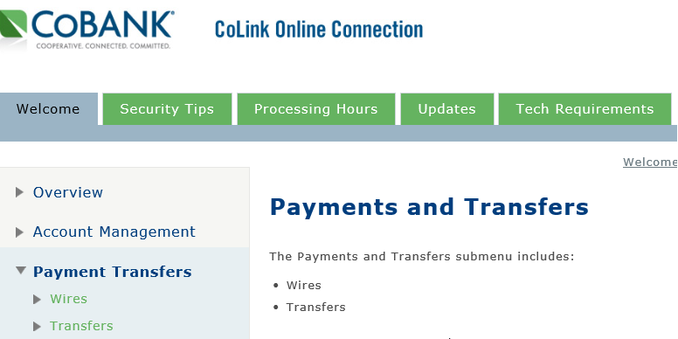

2

**Option 2)**

1. From the home page select **Payments & Transfer**
2. Select **Transfers** in the submenu
3. Select **New Transfer,** located under the blue Dashboard bar
4. Select the **From Account**
5. Select the **To Account**
6. Input the dollar **Amount** to transfer
7. Select the effective **Date**
8. Select **Submit Transfer** until you get back to the transfer screen

