Payments and Transfers Instructions

- From the home page select Payments & Transfers
- Select Wires in the submenu
- Select Book in the dropdown menu for Wire Type
- Select New Wire

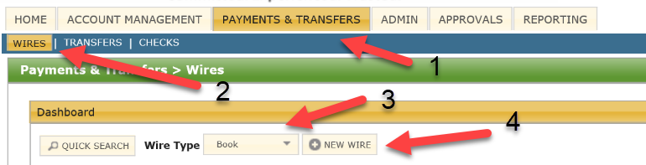

- Select the account to transfer funds from in the Debit Account field
- Input the Dollar Amount
- Select the effective Date
- Input the Account Number to send funds to (8-digit Beneficiary CIF#/ 9- digit Beneficiary Account Number)
- Input the Beneficiary Name
- Select Submit and it will take you back to the wire screen

